1. Created S3 Bucket

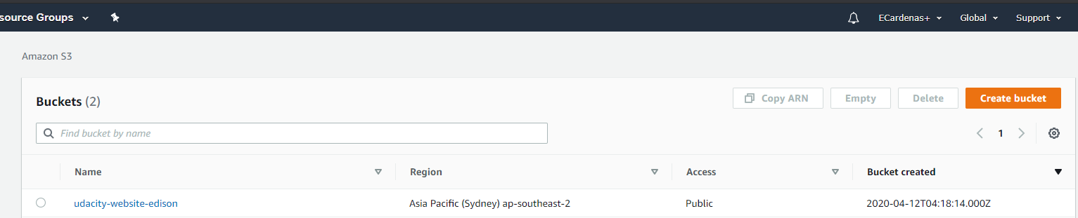

1. Uploaded all website files

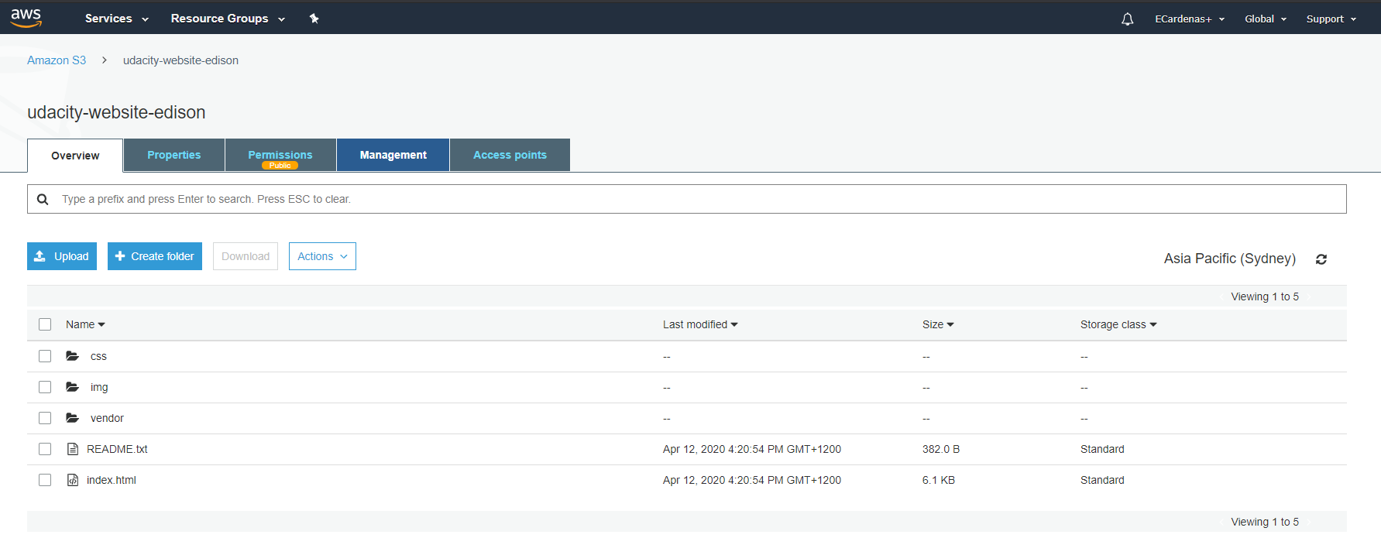

1. The S3 bucket is configured to support static website hosting.

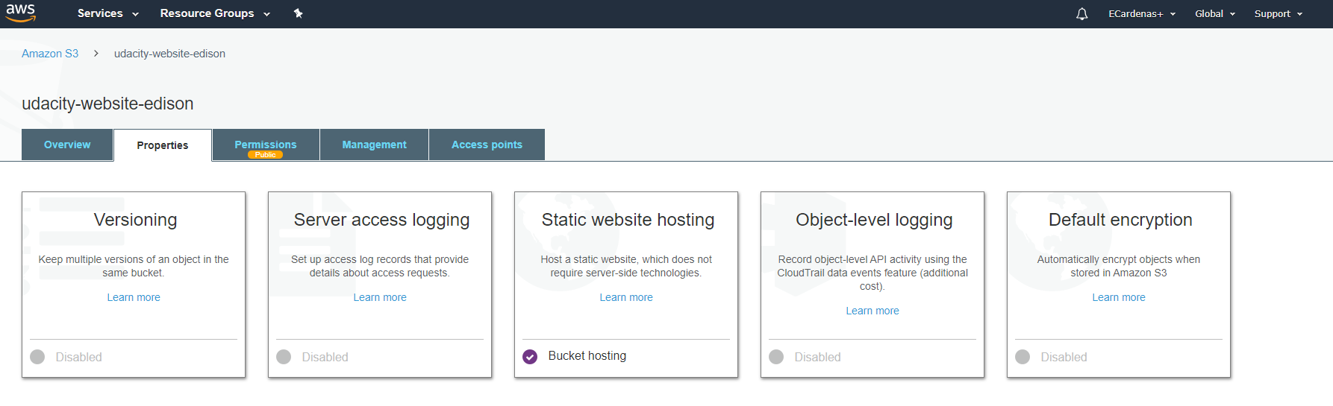

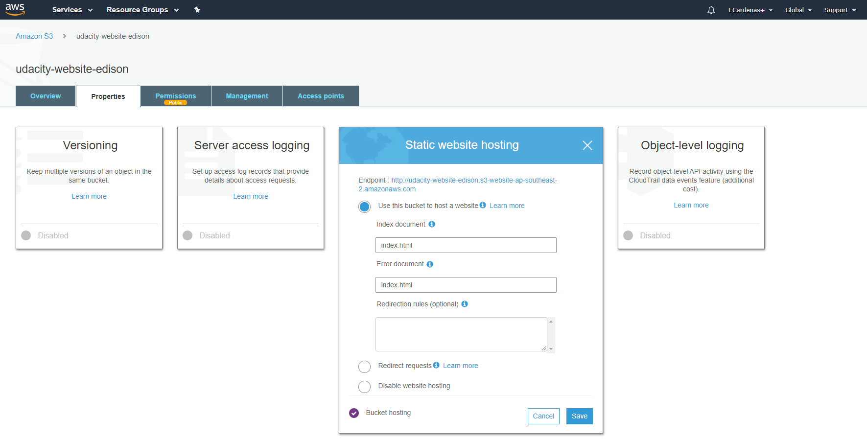

1. The S3 bucket has an IAM bucket policy that makes the bucket contents publicly accessible.

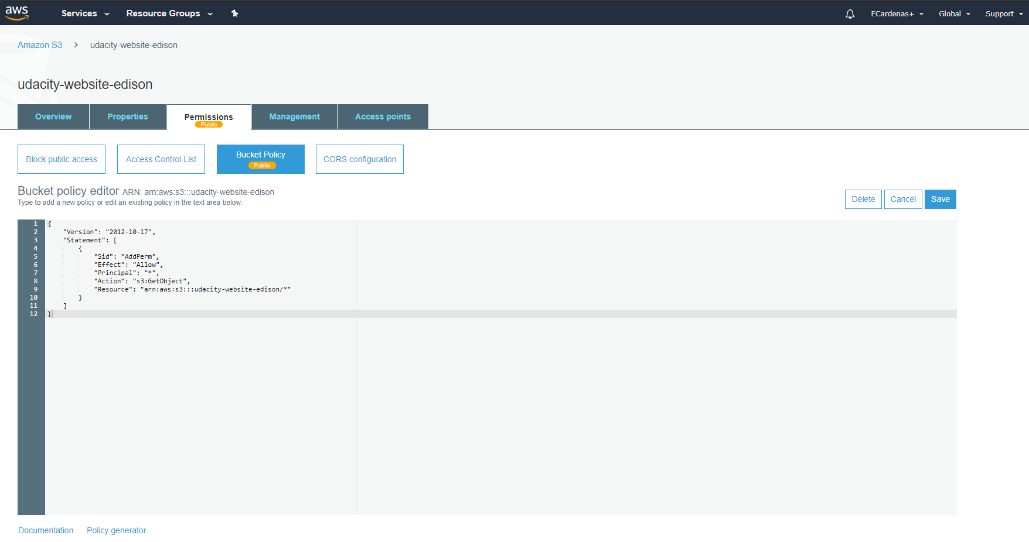

1. CloudFront has been configured to retrieve and distribute website files.

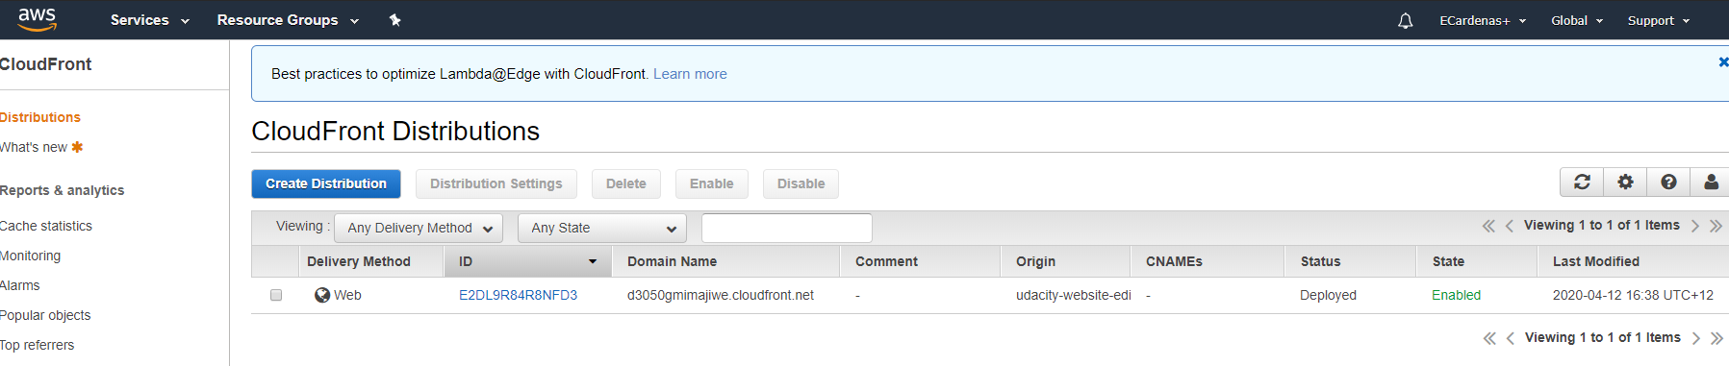

1. The website is accessible to anyone on the Internet via a web browser. CloudFront endpoint URL for the website is: **d3050gmimajiwe.cloudfront.net/index.html**

